**NITTE MEENAKSHI INSTITUTE OF TECHNOLOGY**

(AN AUTONOMOUS INSTITUTION)

(AFFILIATED TO VISVESVARAYA TECHNOLOGICAL UNIVERSITY, BELGAUM, APPROVED BY AICTE & GOVT.OF KARNATAKA)



COURSE-PROJECT REPORT ON

**SOCIAL NETWORKING**

**DATABASE SYSTEM.**

*Submitted by:*

1. PARAS DAHAL(1NT13CS085)

2. SUBROT SUNDEWAR (1NT13CS196)

3. JOSEPH NGABO (1NT13CS072)

In partial fulfillment of the requirements for the completion of *V Semester Database Management System Course-Project work* during the academic year 2015-2016.

Department of Computer Science and Engineering

Nitte Meenakshi Institute of Technology, Yelahanka, Bangalore – 560064

Academic Year 2015-16

**NITTE MEENAKSHI INSTITUTE OF TECHNOLOGY**

(AN AUTONOMOUS INSTITUTION)

(AFFILIATED TO VISVESVARAYA TECHNOLOGICAL UNIVERSITY, BELGAUM, APPROVED BY AICTE & GOVT.OF KARNATAKA)



**CERTIFICATE**

**This is to certify that the Project Report**

**SOCIAL NETWORKING DATABASE SYSTEMS**

Is an authentic work carried out:

1. PARAS DAHAL(1NT13CS085)

2. SUBROT SUNDEWAR (1NT13CS196)

3. JOSEPH NGABO (1NT13CS072)

In partial fulfillment of the requirements for the completion of *V Semester Database Management System Course-Project work* during the academic year 2015-2016.

Name & Signature of the Guide Name & Signature of HOD

**ACKNOWLEDGEMENT**

Any task in the world cannot be accomplished on a sole basis. It directly or Indirectly needs the overt or covert support of their acquaintances, beloved ones or their faculty heads. We have culminated our project with the aid of not only our friends but the assistance provided by our faculties cannot be neglected.

Thus we would like to give a sincere thank to our institute ***"Nitte Meenakshi Institute Of Technology, Bangalore"*** for providing us the platform, in which we have put our raw knowledge of concepts to an implementation level.

We would like to honor our director ***Dr. N. R. Shetty, Director, NMIT-Bangalore*** for the incredible support. He fostered and encouraged us to pursue it to finish it to the rising stars.

Our acknowledgement cannot be complete without mentioning this name who have not only supported us but also showered his experience drops on our project which makes it embelling and a full fledged technology. Being a project guide, ***Mr. Afroz Pasha*** was not centralized by vesting all the power of project to himself. In spite of this he delegated his knowledge to us which helped us to learn a lot.

Last but not least we would like to thank our parents for supporting us to complete our presentation report in all ways.

**TABLE OF CONTENTS**

|  |  |  |
| --- | --- | --- |
| **Sl.No** | **Description** | **Page No.** |
| 1. | Abstract | 1 |
| 2. | Introduction | 2 |
| 3. | Hardware Requirements | 3 |
| 4. | Software Requirements | 4 |
| 5. | E-R Diagram | 5 |
| 6. | Screenshots | 6 |

**ABSTRACT**

Social networking sites have gained much popularity in the recent years, because of the opportunities they give people to connect to each other in an easy and timely manner, and to exchange and share various kinds of information. However, these sites are architected based on a centralized paradigm, which limits the mobility of their users, and ultimately, their chances for establishing new relationships and benefiting from diverse networking services.

In this project, the which users retain control of their profiles, and social networking sites focus on the delivery of innovative and competitive services. Our position is that only in this environment will both the social networking sites and their users be able to develop to their full potential.

**INTRODUCTION**

Social networking is the grouping of individuals into specific groups, like small rural communities or a neighborhood subdivision, if you will. Although social networking is possible in person, especially in the workplace, universities, and high schools, it is most popular online.

This is because unlike most high schools, colleges, or workplaces, the internet is filled with millions of individuals who are looking to meet other people, to gather and share first-hand information and experiences about cooking, golfing, gardening, developing friendships or professional alliances, finding employment, business-to-business marketing and even groups sharing information about the end of the Mayan calendar and the Great Shift to arrive December 21, 2012. The topics and interests are as varied and rich as the story of our universe.When it comes to online social networking, websites are commonly used. These websites are known as social sites. Social networking websites function like an online community of internet users. Depending on the website in question, many of these online community members share common interests in hobbies, religion, or politics. Once you are granted access to a social networking website you can begin to socialize. This socialization may include reading the profile pages of other members and possibly even contacting them.

The friends that you can make are just one of the many benefits to social networking online. Another one of those benefits includes diversity because the internet gives individuals from all around the world access to social networking sites. This means that although you are in the United States, you could develop an online friendship with someone in Denmark or India. Not only will you make new friends, but you just might learn a thing or two about new cultures or new languages and learning is always a good thing.

**HARDWARE REQUIREMENTS**

Processor : Intel Pentium IV 2.0 GHz & above

RAM : 512 MB & above

Hard Disk : 80 GB & above

Monitor : CRT & LCD

Keyboard : Normal or Multimedia

Mouse : Compatible Mouse

**SOFTWARE REQUIREMENTS**

Front End : React JS

Bootstrap

Language : PHP, Javascript, HTML

Back End : PHP

Operating System : Windows XP & above

Browser : Any latest browser

**E-R Diagram**

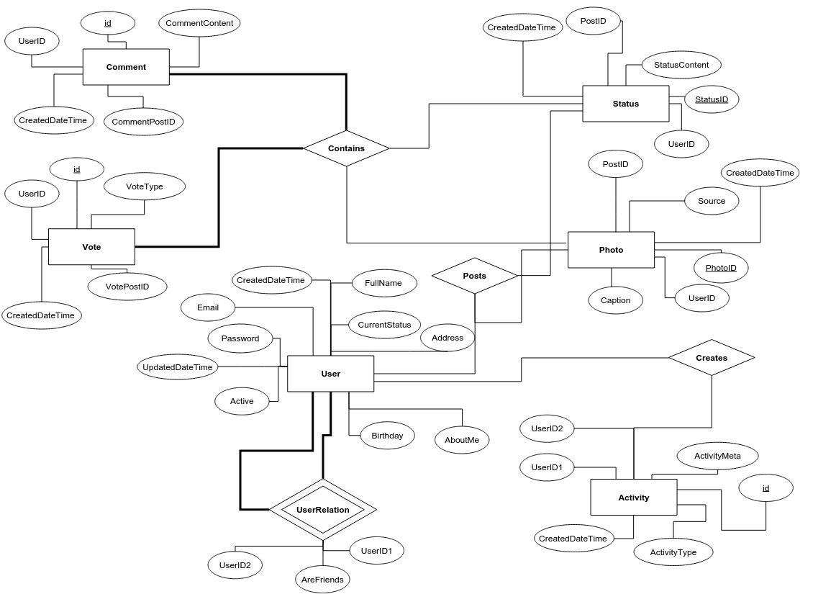

**SCREENSHOTS**

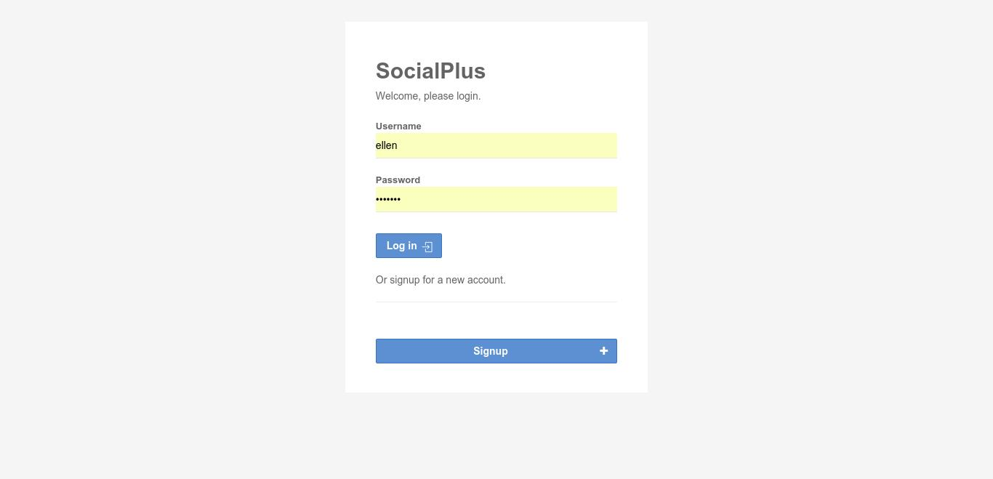

Fig: The login page in the frontend of the social network.

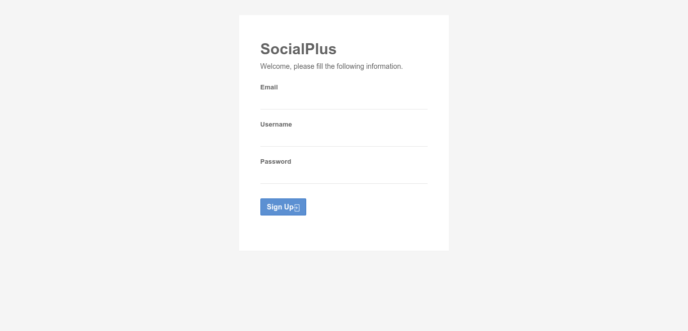

Fig: The signup page in the frontend of the social network.

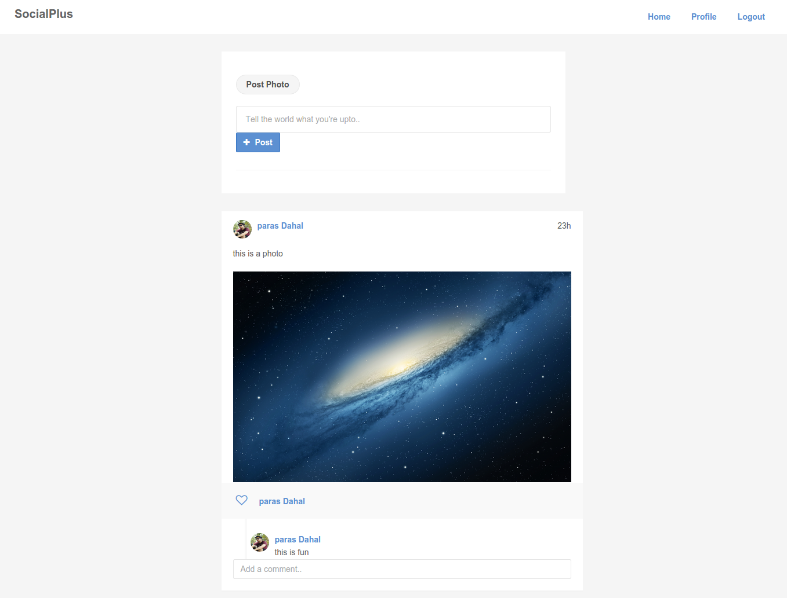

Fig: This is a newsfeed where the status and photo updates done by user that is followed by current logged in user appears. Also, user can post photo and status update from the same page using the topmost statusbox.

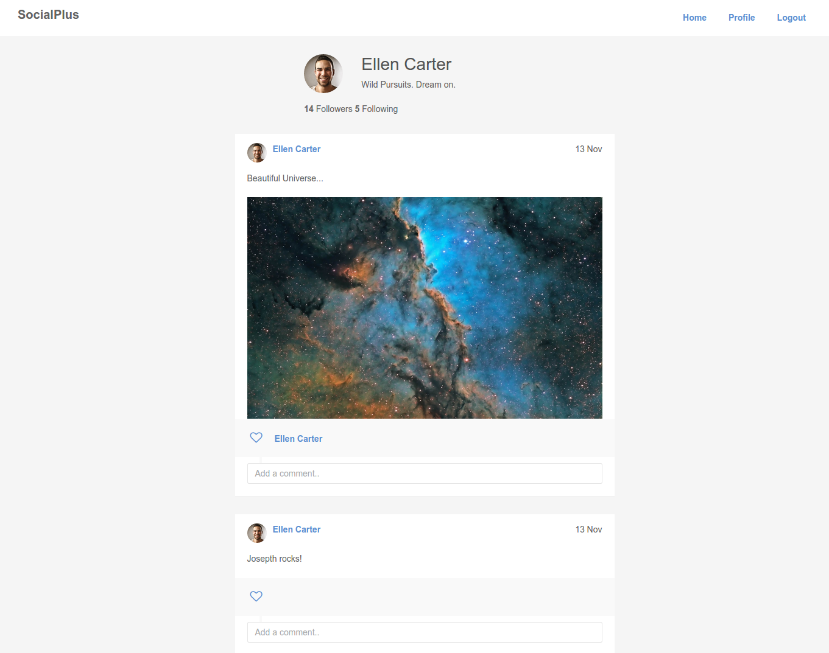

Fig: This is the User profile page that displays the information of the user along with all his posts.